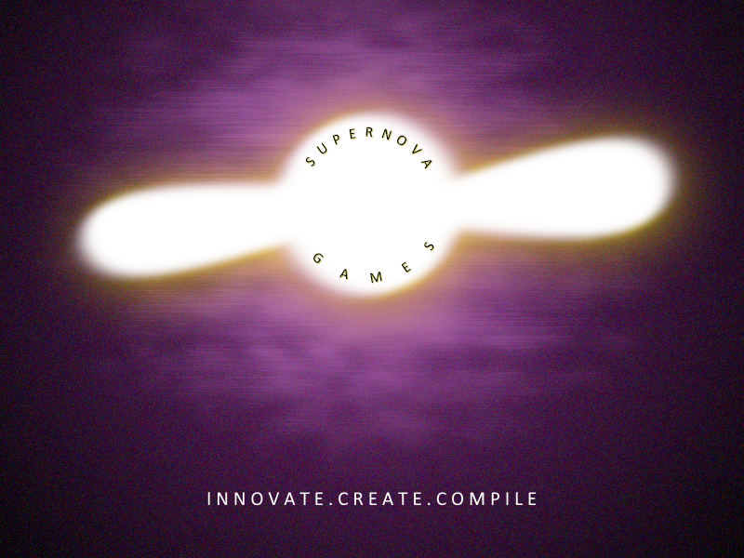

**SuperNova Games**

**‘InBetween’ Video Game Creation and Development**

**Request for Proposal**

**Version 1.2**

**Document History:**

|  |  |  |  |
| --- | --- | --- | --- |
| **Version** | **Date** | **Authors** | **Description** |
| 1.0 | 01/31/2025 | Uday Singh, Braydyn Proctor, Tavin Yorgason, Dax Collins, Zachary Haynie, Gabriel Roy, Liam Garner | Initial draft of the RFP document. |
| 1.1 | 02/03/2025 | Uday Singh, Braydyn Proctor, Tavin Yorgason, Dax Collins, Zachary Haynie, Gabriel Roy, Liam Garner | Revisions and refinements. |
| 1.2 | 02/04/2025 | Uday Singh, Braydyn Proctor, Tavin Yorgason, Dax Collins, Zachary Haynie, Gabriel Roy, Liam Garner | Final version incorporating best aspects. |

**Table of Contents:**

1. Introduction
2. Opportunity
3. Objectives and Goals
4. Similar Systems
5. Intended Users and Their Basic Interactions
6. Known Interactions with Other Systems
7. Known Constraints to Development
8. Project Schedule
9. Proposal Submission Guidelines
10. Key Dates
11. Glossary of Terms

**1.2 Introduction:**

SuperNova Games is seeking a talented development team to bring **"InBetween"**, an atmospheric roguelite game, to life. This document serves as a **Request for Proposal (RFP)** for interested developers to submit their approach to game design, development, and implementation. The selected team will be responsible for creating a **high-quality gaming experience** that balances accessibility for casual players with engaging mechanics for hardcore gamers.

**2.2 Opportunity:**

The roguelike and roguelite genres have seen a surge in popularity, but many titles cater **either to extremely casual or hardcore audiences**. SuperNova Games aims to fill this gap by creating a **balanced experience** that appeals to both.

*"InBetween"* tells the story of a **warrior trapped in purgatory**, fighting to escape into heaven while avoiding the dangers of hell. By **blending engaging combat mechanics, procedural dungeon generation, and an immersive atmosphere**, this game has the potential to **become a worldwide sensation**.

**3.2 Objectives and Goals:**

### **Tone & Atmosphere**

* The game should create a **strong sense of urgency and stakes**, making players feel the weight of their character’s journey.
* Game assets should reflect **medieval, heavenly, demonic, or biblical themes** to enhance immersion.

### **Gameplay Mechanics**

#### **Player Progression**

* XP system that allows players to **earn upgrades**.
* Ability to **upgrade and customize weapons** across various classes.
* Upgradeable base stats (**defense, speed, etc.**).

#### **Dungeon Design**

* **5 procedurally generated dungeon levels**, each with a **unique theme**.
* Dungeon layouts should be built using **pre-designed rooms stitched together dynamically**.

#### **Enemy Design**

* Enemies should be **engaging and varied** to maintain player interest.
* Defeating enemies should **reward XP and progression benefits**.

### **Scope of Work**

The project scope includes:

* **Game Design** – Development of **game mechanics, levels, characters, and storyline**.
* **Game Development** – Coding and implementing **core features, combat, AI, and procedural generation**.
* **Graphics and Sound Design** – Creating **2D sprites, animations, textures, music, and sound effects**.
* **User Interface (UI/UX)** – Designing **menus, HUD elements, and accessibility features**.
* **Quality Assurance (QA)** – **Testing, debugging, and optimizing** to ensure high performance.

**4.2 Similar Systems:**

"InBetween" draws inspiration from:

### **The Binding of Isaac**

* **Room-based dungeon system** similar to its procedurally generated layouts.

### **Hades**

* **Combat mechanics and gameplay flow** inspired by the fast-paced, skill-based action of Hades.
* A **narrative-driven approach** involving the character’s escape from purgatory.

**5.2 Intended Users and Their Basic Interactions:**

* **Target Audience**: Players aged **12-35**, including both casual and hardcore gamers.
* Players will use **keyboard and mouse (PC) or controller (console)** to navigate procedurally generated dungeons, **defeat enemies, earn upgrades, and progress toward the final battle**.

**6.2 Known Interactions with Other Systems**

The game will integrate with major gaming platforms, including:

* **Google Play Store** (Android)
* **Apple App Store** (iOS)
* **Steam** (PC)

**7.2 Known Constraints to Development:**

* **Time Constraints** – The game must be developed within the project schedule.
* **Procedural Generation Complexity** – Ensuring well-balanced levels while maintaining variation.
* **Atmosphere & Art Design** – Creating a **visually compelling experience** with the intended themes.

**8.2 Project Schedule:**

|  |  |
| --- | --- |
| Date | Milestone |
| 8 FEB 2025 | SA Demos Completed. |
| 11 FEB 2025 | Repository chosen and submitted. |
| 21 FEB 2025 | Initial draft of the code should compile and run. |
| 21 MAR 2025 | Production and testing builds created. |
| 4 APR 2025 | Code should resemble a working game (with missing features). |
| 21 APR 2025 | **Final Product Due**. |
| 1 MAY 2025 | **Final Presentation**. |

**9.2 Proposal Submission Guidelines:**

### **Required Documents**

To be considered, proposals must include:

1. **Proposal Document** – Breakdown of the approach, including timelines, deliverables, and pricing structure.
2. **Portfolio/Case Studies** – Examples of previous game development work.
3. **Team Composition** – Details of **team members, their roles, and relevant experience**.
4. **Project Plan** – A **Gantt chart** or other scheduling tool outlining development milestones.

### **Submission Method**

All proposals must be uploaded to the **Class Project GitHub Repository** before the deadline.

**10.2 Key Dates:**

* **Proposal Submission Deadline:** 8 FEB 2025 (2359 PST)
* **Winner Announcement:** 10 FEB 2025

**11.2 Glossary of Terms:**

* **UI/UX** – User Interface and User Experience design, ensuring ease of use.
* **Roguelike** – A genre where **players restart from the beginning upon death**.
* **Roguelite** – A variation where players **retain some progress** between runs.
* **Procedural Generation** – A method of creating game levels dynamically rather than manually.
* **Game Engine**: The software framework used to create and develop video games (Unity Engine).
* **Alpha/Beta Testing**: Stages in the development process where the game is tested by a selected group of users for feedback and bug reporting.

### **Final Notes:**

SuperNova Games looks forward to reviewing proposals from talented developers eager to bring "InBetween" to life. This is an exciting opportunity to create an innovative and engaging roguelite experience that **caters to both casual and hardcore gamers alike**.